**Class Practice - 1**

**MIS 64038**

1. **Plot the following using ggplot():**

ggplot(cars, aes(x=displ, y = hwy)) +

geom_point()

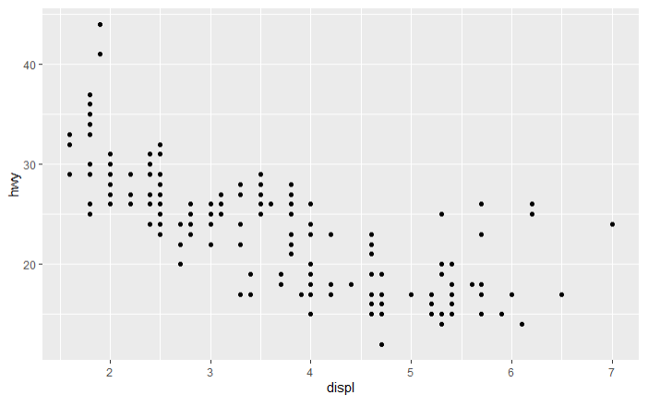

2. How would you describe the relationship between cty and hwy (plot graph using ggplot)? Do you have any concerns about drawing conclusions from that plot?

There is a negative correlation between the 2 variabes.

3. Plot the following graph and explain the output:

ggplot(mpg, aes(model, manufacturer)) + geom_point()

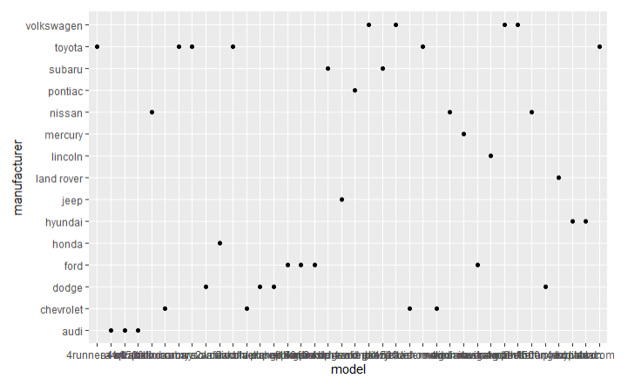

It appears that there are multiple different models for the cars.

4. Is the above graph useful? How could you modify the data to make it more informative?

The best approach might be to aggregate it and get a count for each manufacturer how many models they sell and then plot a graph descending for each manufacturer what their count is.